**Task: LGC Angular Application**

Code scaffolding

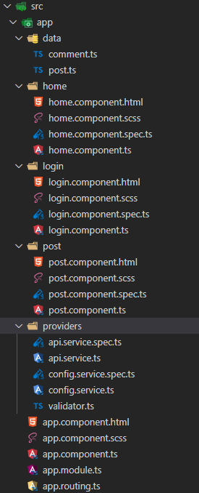

* Login Component: Parameter -> Name, Mobile , Email ( Form Validation Used)

Test Case: To check input if correct.

* Home Component: Displays all the posts received from backend (Deployed on heroku) consumes *data.json* file.
* Post Component: Displays individual post on a separate page with option to add comment, edit comment.

Frontend Templates Used : <https://www.creative-tim.com/product/argon-design-system-angular>

**GitHub Repository:**

Frontend : <https://github.com/aviral282/LetsGetChecked-Frontend>

Backend : <https://github.com/aviral282/LetsGetChecked-Backend>

Android Application : <https://github.com/aviral282/LetsGetChecked-Frontend/raw/apk/app-debug.apk>

**CI Pipeline:**

Frontend : <https://github.com/aviral282/LetsGetChecked-Backend/actions>

Backend : <https://github.com/aviral282/LetsGetChecked-Backend/actions>